2.3 Linear Inequalities

Review of Interval Notation
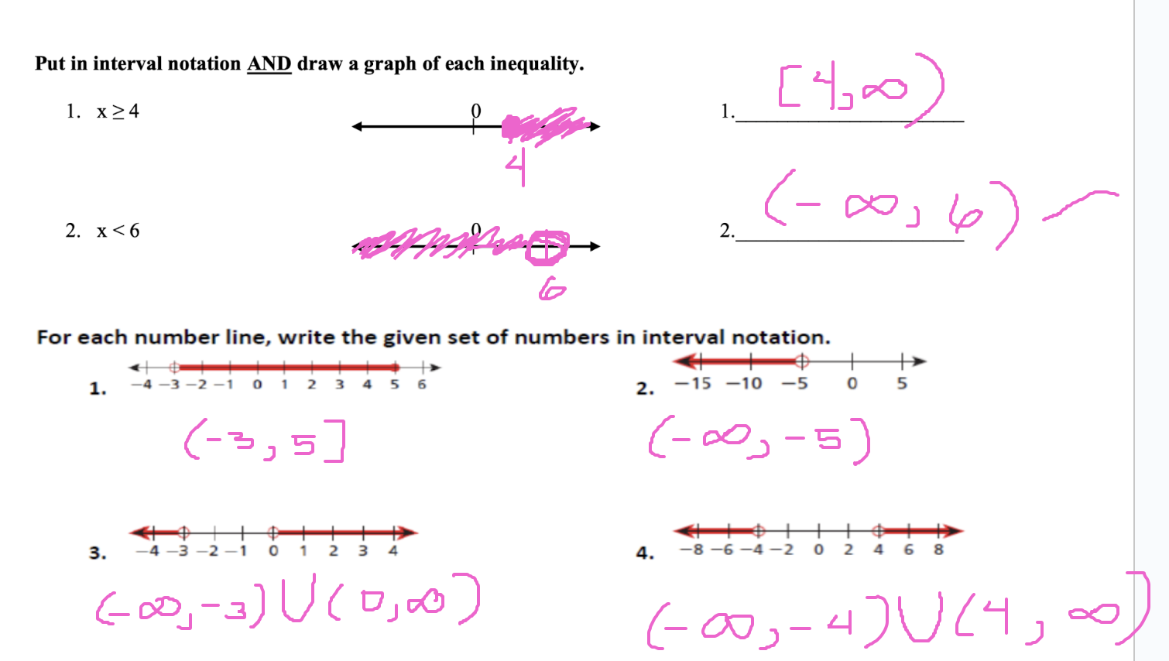

Inequalities in One Variable

An inequality is a statement where the two quantities are not equal (>, <, ≥, ≤)

A linear inequality has the form ax + b > c.

Example of linear inequalities:

3x + 5 > 2
2x ≤ 6

Solve: 3x + 5 > 2

Key information: An equation has a solution where x is equal to a number.
3x + 5 = 2 has x = -1 as a solution.

But the solution to an inequality is often an interval.

3x + 5 > 2
-5 -5
3x/3 > -3/3

x > -1

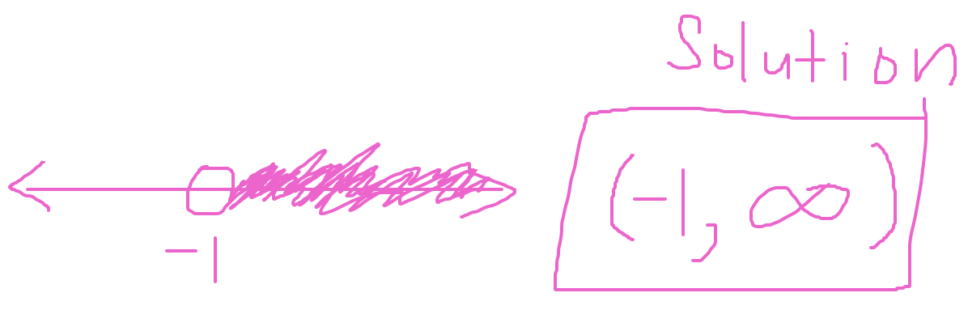

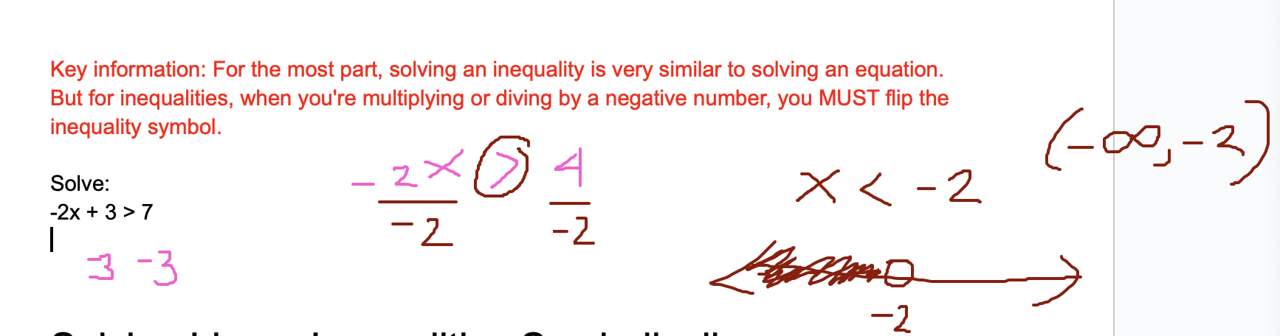

Solving Linear Inequalities Symbolically

Example: Solving a linear inequality
Solve each inequality. Write the solution set in set-builder and interval notation.

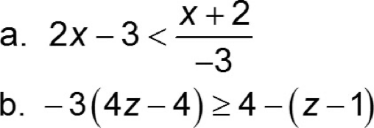

Solving Linear Inequalities Graphically
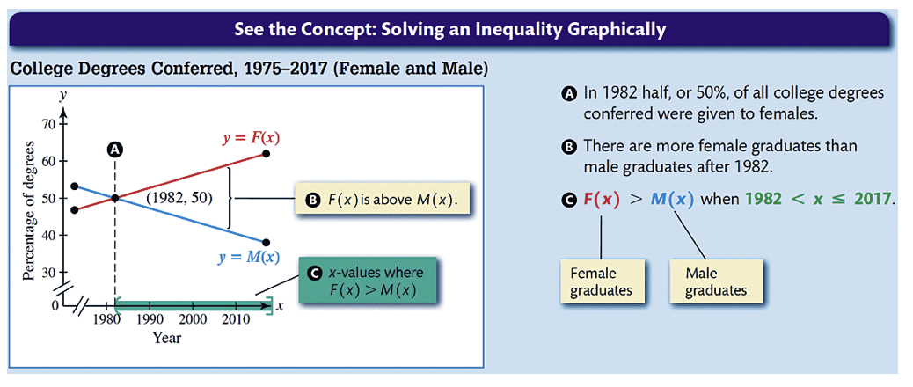

Example: Solving a linear inequality graphically
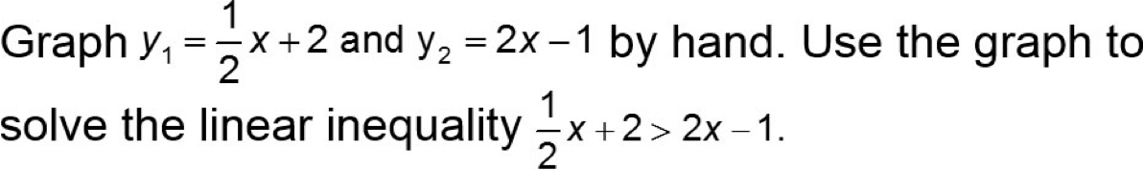

x-intercept Method

If a linear inequality can be written as y₁ > 0, where > may be replaced by ≥, ≤, or <, then we can solve this inequality by using the x-intercept method. To apply this method for y₁ > 0, graph y₁ and find the x-intercept. The solution set includes x-values where the graph of y₁ is above the x-axis.

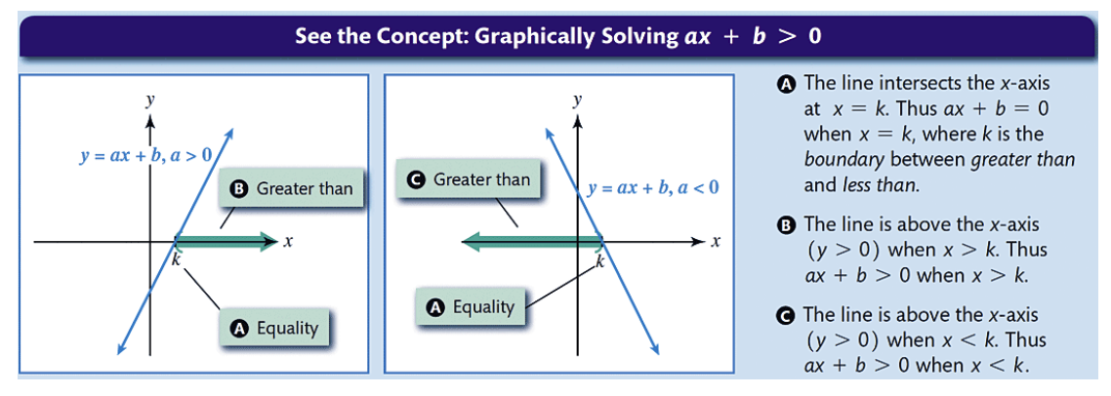

Compound Inequalities

A compound inequality occurs when two inequalities are connected by the word and or or. When the word "and" connects two inequalities, the two inequalities can sometimes be written as a three-part inequality.
x ≥ 40 and x ≤ 70
can be written
40 ≤ x ≤ 70

Example: Solving a compound inequality

